[](https://ok.ru/dk?cmd=PopLayerPhoto&st.layer.cmd=PopLayerPhotoOuter&st.layer.type=GROUP&st.layer.revNav=off&st.layer.limitedUi=false&st.layer.closeLayers=off&st.layer.sphotoIds=852831701097;852831700841;852831700585;852831700329&st.layer.showNav=on&st.layer.photoAlbumId=54400397344873&st.layer.epm=off&st.layer.photoId=852831701097&st.layer.opl=off&st.layer.navStartPhotoId=852831701097&st.layer.sbd=off&st.cmd=altGroupForum&st.groupId=54400390725737&st._aid=GroupTopicLayer_openPhotoLayer) [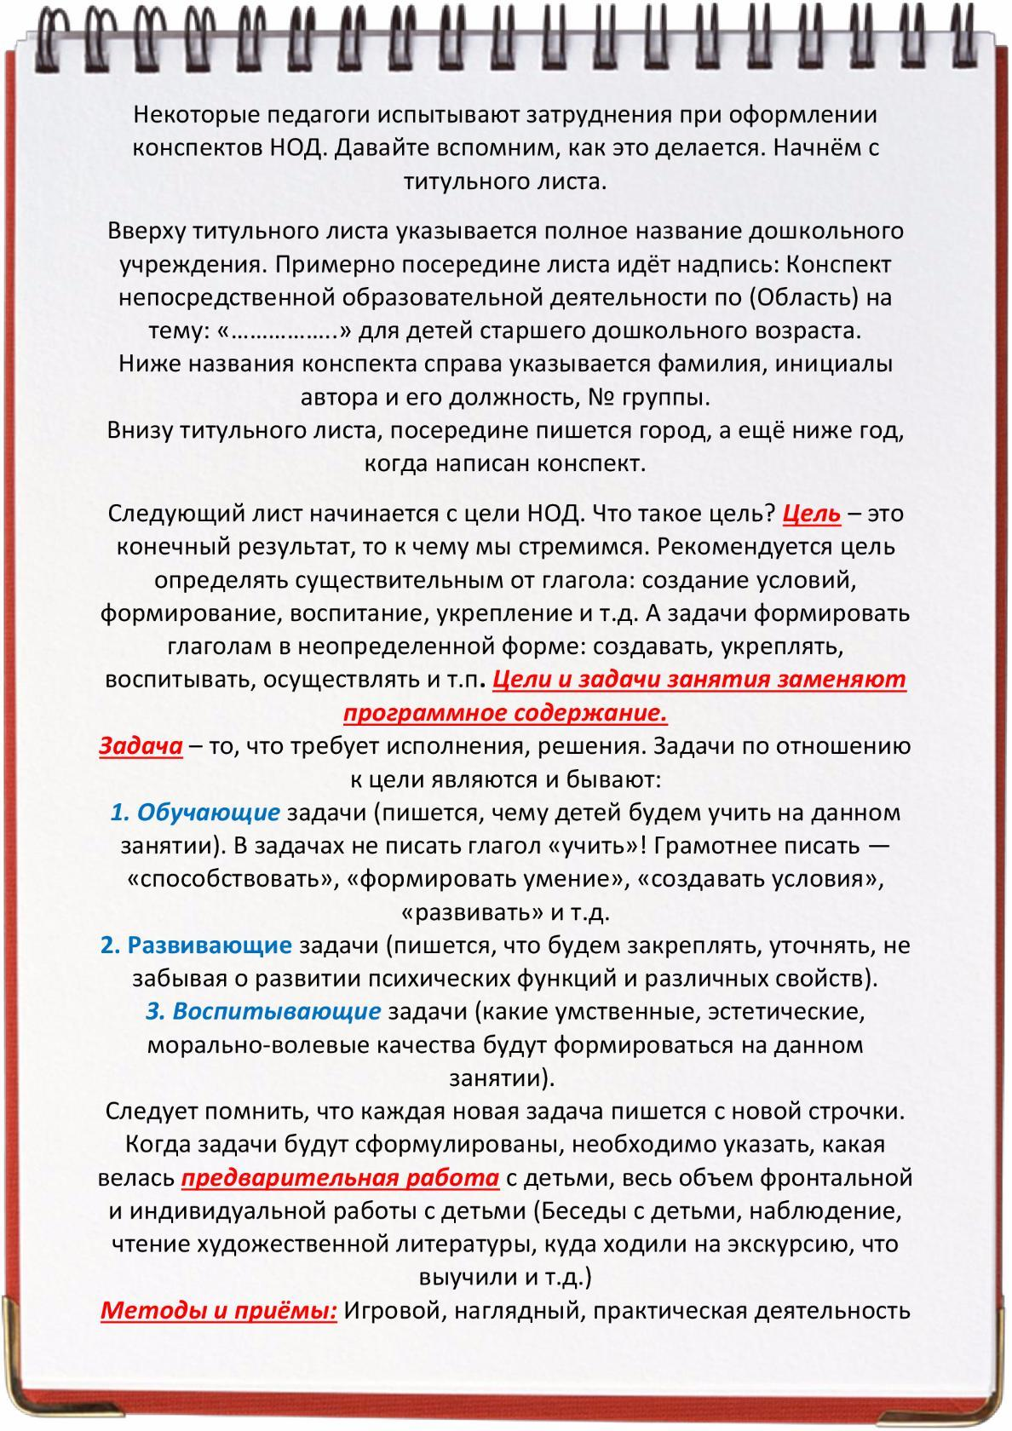](https://ok.ru/dk?cmd=PopLayerPhoto&st.layer.cmd=PopLayerPhotoOuter&st.layer.type=GROUP&st.layer.revNav=off&st.layer.limitedUi=false&st.layer.closeLayers=off&st.layer.sphotoIds=852831701097;852831700841;852831700585;852831700329&st.layer.showNav=on&st.layer.photoAlbumId=54400397344873&st.layer.epm=off&st.layer.photoId=852831700841&st.layer.opl=off&st.layer.navStartPhotoId=852831700841&st.layer.sbd=off&st.cmd=altGroupForum&st.groupId=54400390725737&st._aid=GroupTopicLayer_openPhotoLayer)

[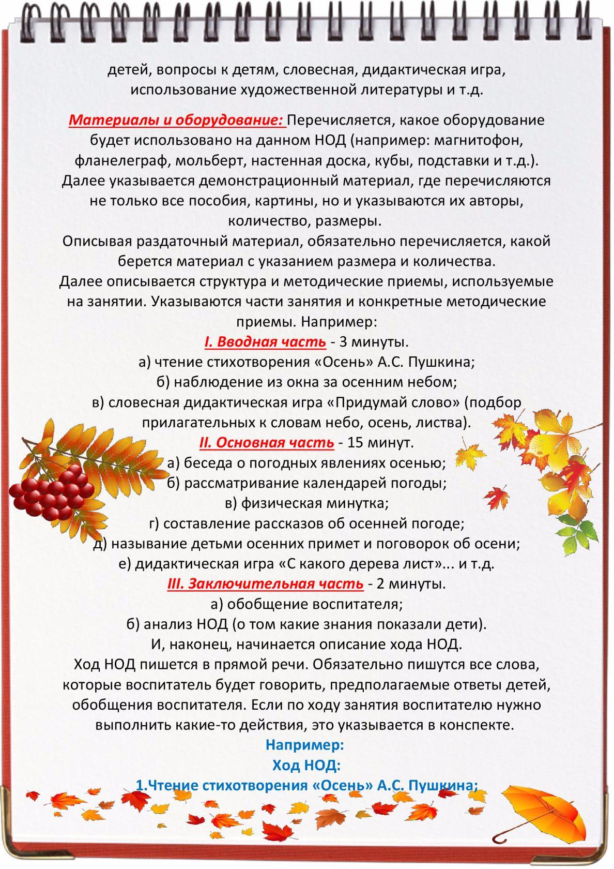](https://ok.ru/dk?cmd=PopLayerPhoto&st.layer.cmd=PopLayerPhotoOuter&st.layer.type=GROUP&st.layer.revNav=off&st.layer.limitedUi=false&st.layer.closeLayers=off&st.layer.sphotoIds=852831701097;852831700841;852831700585;852831700329&st.layer.showNav=on&st.layer.photoAlbumId=54400397344873&st.layer.epm=off&st.layer.photoId=852831700585&st.layer.opl=off&st.layer.navStartPhotoId=852831700585&st.layer.sbd=off&st.cmd=altGroupForum&st.groupId=54400390725737&st._aid=GroupTopicLayer_openPhotoLayer)[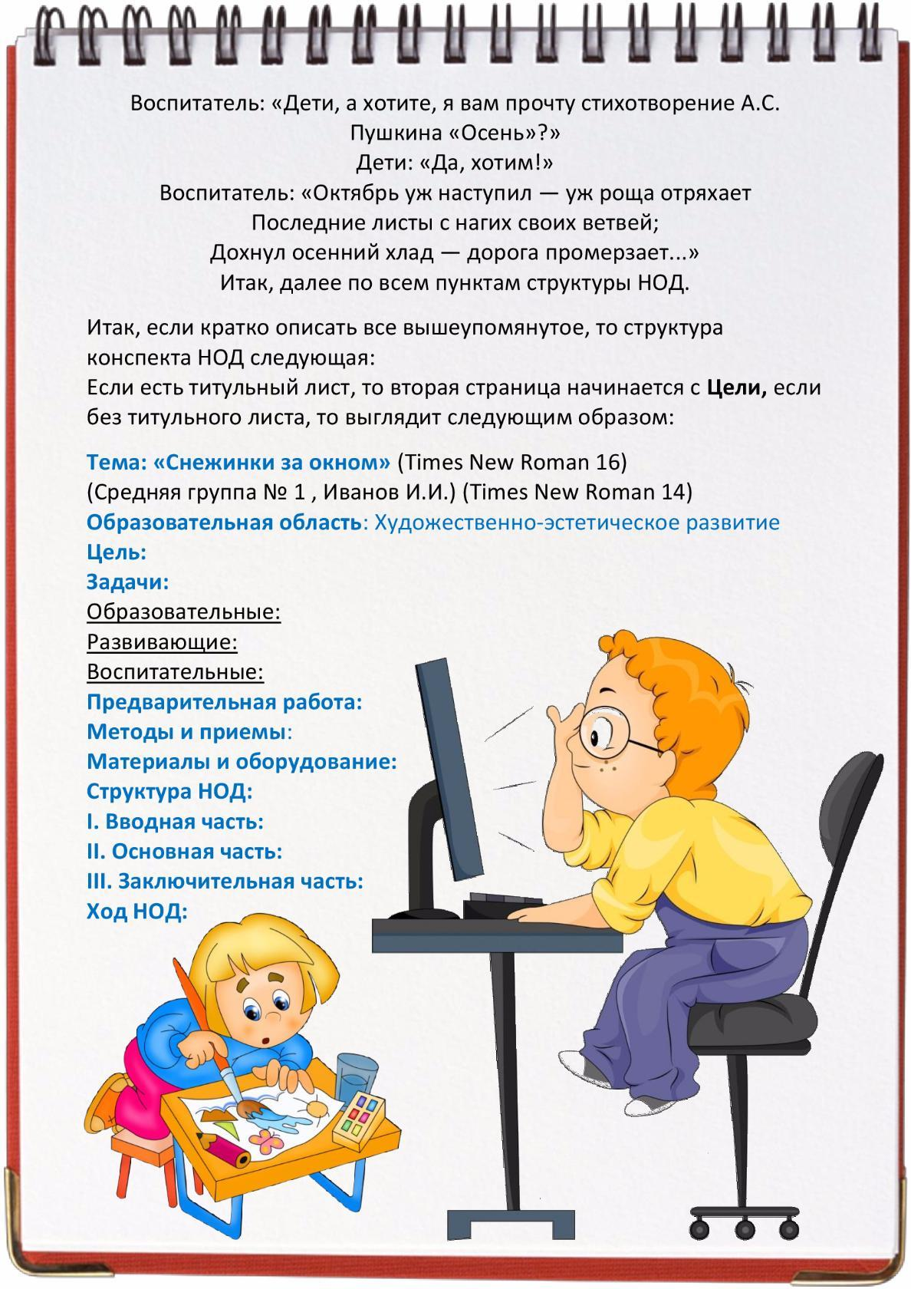](https://ok.ru/dk?cmd=PopLayerPhoto&st.layer.cmd=PopLayerPhotoOuter&st.layer.type=GROUP&st.layer.revNav=off&st.layer.limitedUi=false&st.layer.closeLayers=off&st.layer.sphotoIds=852831701097;852831700841;852831700585;852831700329&st.layer.showNav=on&st.layer.photoAlbumId=54400397344873&st.layer.epm=off&st.layer.photoId=852831700329&st.layer.opl=off&st.layer.navStartPhotoId=852831700329&st.layer.sbd=off&st.cmd=altGroupForum&st.groupId=54400390725737&st._aid=GroupTopicLayer_openPhotoLayer)